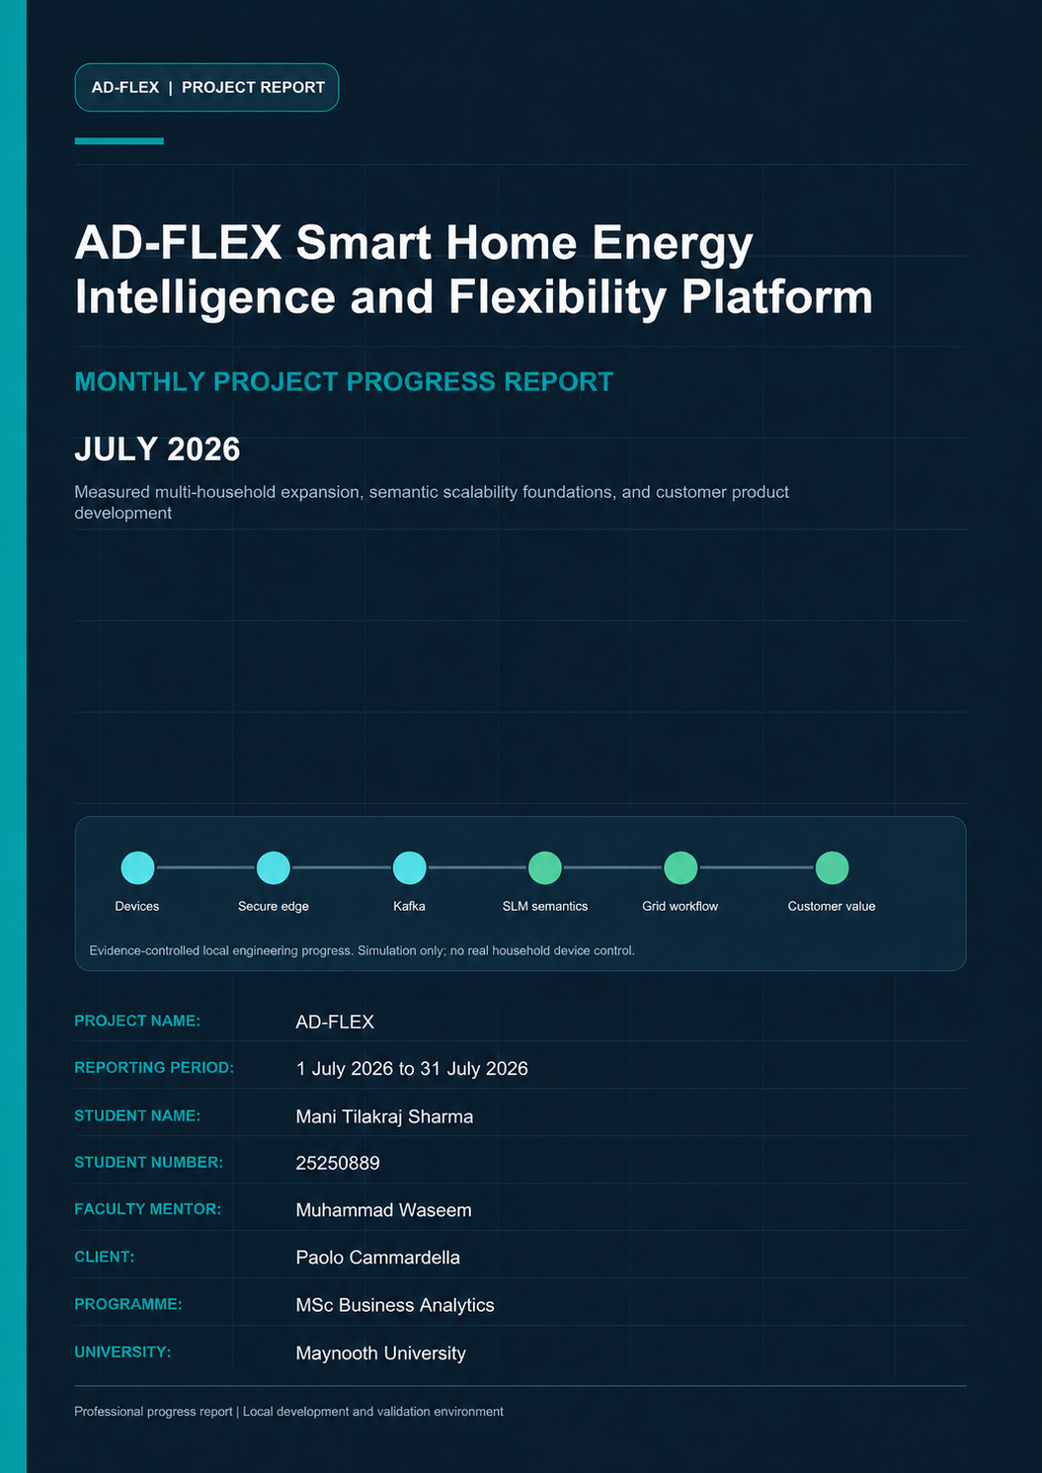

Document Control
Project Name | AD-FLEX
Document | AD-FLEX Monthly Project Progress Report - July 2026
Reporting period | 1 July 2026 to 31 July 2026
Student Name | Mani Tilakraj Sharma
Student Number | 25250889
Faculty Mentor | Muhammad Waseem
Client | Paolo Cammardella
Programme | MSc Business Analytics
University | Maynooth University
Version | 1.0
Document date | 13 August 2026
Distribution | Paolo Cammardella, Muhammad Waseem, academic review, and technical management

Evidence and claim standard
Git history is the primary implementation timeline. Live results are included only where the repository contains a dated report or machine-readable artifact. Implemented, validated, demonstrated, planned, and future-production items remain distinct throughout this document.

Protocol and dataspace references describe simplified IEEE 2030.5-style and ENERSHARE/IDS-ready foundations. They do not assert certification. All device-command evidence is simulated and retains no_real_execution=true.
This report should be read with the month-specific evidence audit and the July-August cross-month consistency check retained in docs/monthly-reports.

Table of Contents
The contents follow the report heading hierarchy. Page numbers appear in the document footer.
1. Executive Summary
2. Project Objective
3. Position at the Start of the Month
4. Monthly Development Focus
5. Major Work Completed
6. End-of-Month Architecture
7. Component Progress
8. SLM and Semantic Intelligence
9. Household and Device Simulation
10. Scalability Development
11. Validation and Testing
12. Customer/Product Development
13. Business Value for EnerShare
14. Technical Challenges and Resolutions
15. Safety, Security and Governance
16. End-of-Month Project Status
17. Next Development Priorities
18. Monthly Achievement Summary
19. Conclusion
Appendix A - Git Evidence
Appendix B - Validation Evidence
Appendix C - Current Limitations

1. Executive Summary
July was a transition month for AD-FLEX. The repository entered the month with the complete Phase 1-9 local workflow already present: secure HTTP/MQTT ingestion, Kafka, TimescaleDB, normalization, local semantic interpretation, simplified IEEE 2030.5-style translation, flexibility proposals, approval, mock dispatch, simulated device translation, dataspace export, and an operator console. Development therefore concentrated on evidence, scale, resilience, and the separation of a customer product from engineering operations.
The first major result was a measured five-household demonstration. Fifteen independently simulated assets produced 30 telemetry messages and 120 normalized readings. All messages reached raw, semantic-terminal, and IEEE-style stages without drops, duplicate final rows, or processing errors. Local Phi-3 Mini was called for every reading. Eighty mappings were accepted as SLM primary, ten used the deterministic fallback policy still active at that point, and thirty were safely left unmapped when semantic guardrails rejected the model result. The complete DSO-to-approval-to-mock-dispatch-to-device-translation path also completed with no_real_execution=true.
Later on 20 July, the semantic path was redesigned for mandatory-SLM scalability. The connector gained reading-level micro-batching, strict JSON output, provider abstraction for Ollama and a future vLLM-compatible endpoint, retry and dead-letter topics, durable SLM audit evidence, stable reading identity, bounded concurrency, lag metrics, and replay-safe processing. A first 100-device capacity gate deliberately failed: 400 normalized readings arrived faster than one local Phi-3 Mini worker could complete them, 56 readings lacked terminal audit evidence at the gate, and final Kafka lag remained 112. The failure prevented unsupported progression to 1,000, 5,000, or 10,000 devices and identified local inference as the dominant constraint.
Customer productisation followed on 24 July. A role-aware EnerShare dashboard was added alongside the preserved technical console. Customer routes use bounded TimescaleDB views, security-gateway authorization, pseudonymized household selection, server-side aggregation, and Next.js backend-for-frontend routes. Household users are isolated to their own household; operators receive scoped, pseudonymized views; technical administrators retain /admin/operations. Customer-facing AI insights are generated from bounded aggregates and validated facts rather than exposing prompts or model diagnostics. Lint, build, access-control, responsive, gateway, semantic, and full-workflow checks passed.
By 26 July, one bounded fleet process represented 20 mixed-profile households and 241 simulated devices across 13 categories. It used one scheduler rather than one process, thread, or timer per device. All devices reached raw and normalized storage, and the protected customer dashboard was exposed temporarily through a free Cloudflare Quick Tunnel without exposing Kafka, TimescaleDB, Ollama, MQTT, or internal services. The fleet and customer experience worked; semantic capacity did not. Of 3,041 completed SLM audit rows, only one strict mapping passed and 3,040 became safely unmapped. This transparent result reinforced that delivery scale and semantic scale are separate concerns.
At month end, AD-FLEX had a stronger technical and product foundation, clearer privacy and safety boundaries, and quantitative evidence of its next bottleneck. Late-July machine-readable files, versioned on 5 August, also record an asynchronous functional run with exactly 100 households and 1,000 assets. That evidence is acknowledged with its provenance, while the August report covers formal integration and fresh 5 August validation. The July position is therefore credible but not overstated: full workflow integrity was validated at 15 assets; a larger fleet and public product were demonstrated; and SLM throughput remained the key engineering priority.
July management conclusion
The platform moved from a technically complete local pipeline to a measured multi-household, customer-facing, scale-aware system. The principal unresolved issue was local Phi-3 Mini throughput and strict structured-output quality under larger continuous workloads.

2. Project Objective
AD-FLEX is a smart-home energy intelligence and flexibility platform for EnerShare. Its purpose is to receive heterogeneous household device telemetry, normalize it, create a common semantic interpretation, store an auditable time-series record, and make the information useful for household insight and grid flexibility. The architecture combines event streaming, local small-language-model interpretation, deterministic SAREF4ENER validation, grid-protocol translation, governed approval, simulated command preparation, and privacy-aware sharing.
The project addresses a practical integration problem: manufacturers describe energy measurements and states differently. AD-FLEX converts those differences into standardized energy information while retaining source identity and evidence. Grid requests can then move through a controlled flexibility workflow, and approved outcomes can be translated into simulated Shelly, Enode/Easee, and heat-pump device language. The July work concentrated on making this chain observable, safer at larger workloads, useful to customers, and honest about the capacity boundary of local inference.

3. Position at the Start of the Month
The last pre-July commit was 3d90ee6 on 15 June. Table 1 establishes the baseline so that existing functions are not counted as July delivery.
Table 1. Verified project baseline before 1 July 2026
Area | State before July | July reporting treatment
Core telemetry | HTTP/MQTT, raw.telemetry, normalization, normalized.telemetry | Baseline only
Semantic layer | Local Phi-3/Ollama and SAREF4ENER support already present | July hardening and scale work only
Grid workflow | IEEE-style translator, DSO signal, aggregator, approval, mock dispatch | Baseline; validated at larger scope
Device integration | Shelly, Enode/Easee, and heat-pump simulators plus translator | Baseline; richer telemetry and fleet expansion
Sharing and edge | Dataspace export and security gateway | Baseline; product/public-demo integration
Customer UI | Technical customer operator console | Reworked into product plus operations separation

4. Monthly Development Focus
Repository changes show that July development focused on the following practical objectives:
Validate more than one household and preserve independent device behavior.
Make mandatory local SLM processing auditable and scalable through batching, retry, provider abstraction, and durable identity.
Measure the first capacity limit rather than treating Kafka acceptance as end-to-end success.
Separate a household/customer product from internal engineering diagnostics.
Introduce privacy-aware, role-scoped customer reads and validated aggregate AI insights.
Represent many devices in a bounded fleet process and demonstrate a secure, no-cost public dashboard path.
Retain all simulation, approval, audit, and no-real-execution controls.
Figure 1 summarizes the progression and the claim boundary applied to the month.
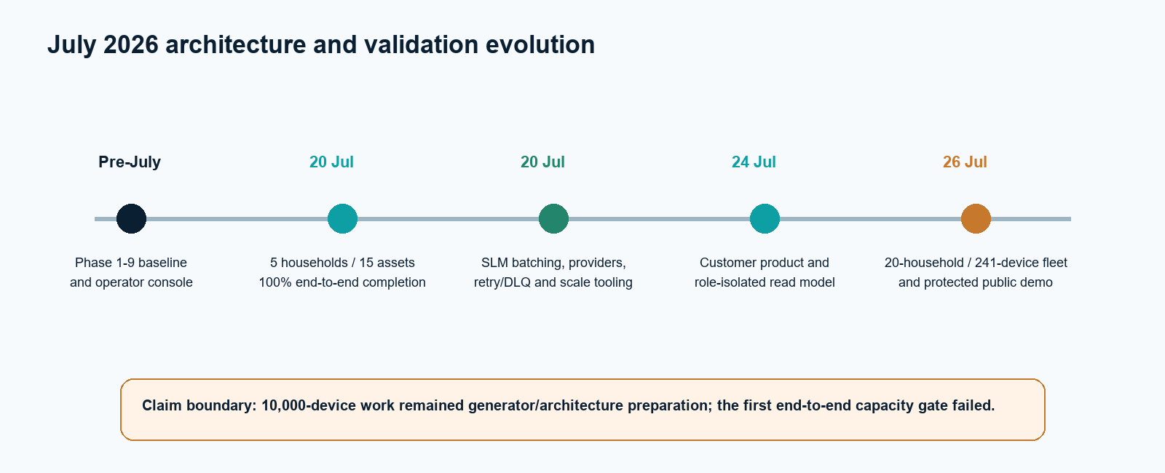
Figure 1. July development timeline from the pre-July baseline to the bounded fleet and protected public demonstration.

5. Major Work Completed

5.1 Multi-household simulation and measured end-to-end workflow
Previous state | The repository had individual Shelly, Enode/Easee, and heat-pump simulator APIs, but no reusable measured workload showing several households operating independently.
Change made | A seeded five-household runner created one device of each supported family per household, enriched the telemetry fields, and streamed run evidence.
Reason | EnerShare needed proof that the same logical workflow could preserve household and device identity beyond a single demonstration asset.
Technical implementation | The shared BaseDevice contract gained elapsed-time and seeded state helpers. Shelly added voltage, current, and cumulative energy; the charger added charging state and delivered energy; the heat pump added target temperature and operating mode. Semantic consumer-session timing was extended to cover long local inference calls.
Validation | The final run accepted 30 of 30 gateway requests, created 120 normalized readings, persisted 120 terminal semantic records and 120 IEEE-style rows, and recorded no drops, final duplicates, or processing errors. The DSO, approval, mock dispatch, device translation, MQTT probe, dashboard, and dataspace path also completed.
EnerShare value | The result demonstrated identity-safe processing for multiple households and provided EnerShare with measured evidence rather than a single-device proof of concept.
Current status | Implemented and validated locally on 20 July. The result is a production-style functional demonstration, not a maximum-capacity benchmark.

5.2 SLM scalability architecture
Previous state | The SLM-primary connector operated reading by reading and did not provide a complete scalable provider, retry, lag, and evidence framework.
Change made | Reading micro-batching, strict batch output, provider independence, durable SLM audit records, retry/DLQ topics, worker identity, lag metrics, and scalable workload tooling were added.
Reason | Every normalized reading must reach an SLM, but serial local inference cannot support increasing arrival rates. Safe scaling requires batching and auditable terminal outcomes rather than deterministic bypasses.
Technical implementation | A provider interface supports Ollama and a vLLM-compatible OpenAI endpoint. Each response is reconciled by reading_id and checked for concept, property, unit, confidence, and command safety. Rejected/missing results are retried and then stored safely unmapped. Offsets advance only after durable completion.
Validation | Provider benchmarks measured 0.294 readings/s at batch 1, 0.616 at batch 4, and 0.601 at batch 8. The first 100-device gate failed with 86% terminal SLM evidence and final lag 112; later stages were not run.
EnerShare value | The architecture creates an evidence-backed path to horizontal inference capacity and prevents an unreliable model result from becoming an unverified business data product.
Current status | Implemented as a local scalability foundation. A 10,000-device population could be represented by the generator, but 10,000-device end-to-end processing was not validated.

5.3 Customer-facing EnerShare dashboard
Previous state | The console concentrated on topics, services, raw technical payloads, and validation workflows. Authentication had no complete household/community role scope.
Change made | A separate product route family was added for household overview, analytics, devices, flexibility, community, reports, and settings; technical operations were preserved at /admin/operations.
Reason | Household and portfolio users need energy and flexibility outcomes, while engineers need pipeline diagnostics. Mixing the two creates privacy, usability, and claim risks.
Technical implementation | TimescaleDB read views and indexes feed a security-gateway customer read model. Signed sessions contain role and scope. Next.js BFF routes attach server-only authorization. Operators see stable pseudonyms, household users are fixed to one household, and community comparisons are aggregated and suppressed for small groups.
Validation | Customer authorization, metrics, insight validation, terminology, lint, build, responsive layout, empty/error states, and the full gateway workflow passed. Live data produced 6.19 kW household power and 1.55 kWh bounded daily estimate without hardcoded UI values.
EnerShare value | EnerShare gained a credible household intelligence experience while preserving the technical console for operations and validation teams.
Current status | Implemented and validated for the local demonstration. Authentication remains a signed local session rather than a production identity provider.

5.4 Household fleet and protected public demonstration
Previous state | The five-household runner was finite and used only three device families. The dashboard was local and the read model lacked durable inventory metadata for broader categories.
Change made | One bounded household-fleet service represented 20 mixed-profile households and 241 devices across 13 categories. A device registry, pagination, detail views, public-mode BFF routes, login throttling, loopback port bindings, and Quick Tunnel scripts were added.
Reason | A customer demonstration required richer household composition, bounded server/browser behavior, and remote access without exposing internal infrastructure or purchasing cloud services.
Technical implementation | The fleet stores current state and next emission time per virtual device, uses one scheduler and bounded concurrency, spreads initial telemetry, and retains one pending envelope per failed delivery. Cloudflare terminates at Next.js only; the browser uses same-origin APIs and server-side gateway credentials.
Validation | All 241 devices and 13 categories reached raw and normalized storage. 3,436 generated messages were accepted after six bounded retries and zero drops. Product pagination, cross-household rejection, mobile layouts, login throttling, public tunnel loading, and tunnel shutdown passed.
EnerShare value | EnerShare could demonstrate a realistic portfolio and customer product from one laptop with a controlled public boundary and no billable hosting.
Current status | Demonstrated locally. Semantic completion did not keep pace; 3,040 of 3,041 completed SLM rows were safely unmapped, so this was not a full semantic scalability pass.

6. End-of-Month Architecture
Figure 2 presents the committed July end-state. It intentionally shows the bounded 20-household fleet rather than treating the later 1,000-asset integration as a completed July architecture release.
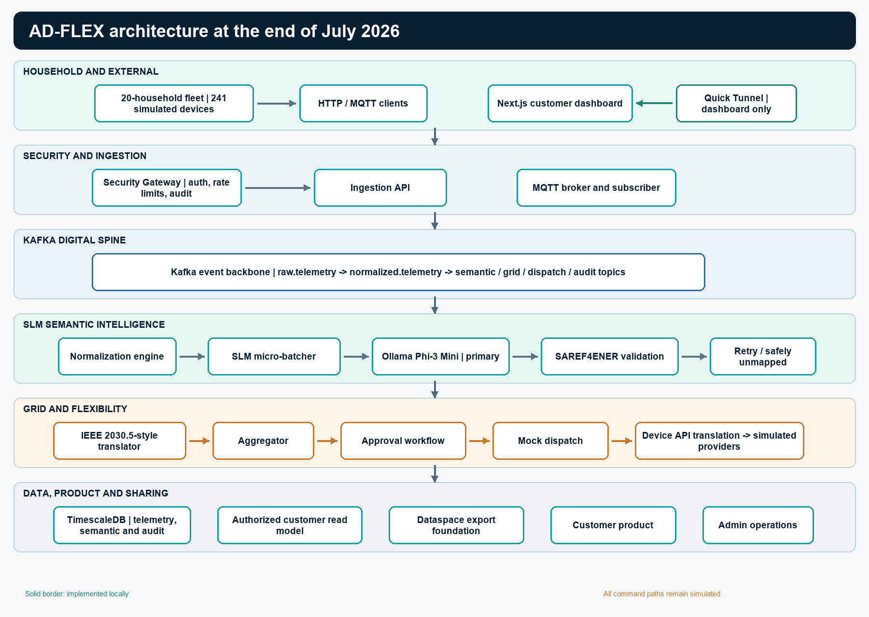
Figure 2. Layered AD-FLEX architecture at the end of July 2026. All command paths remain simulated.

External and simulated sources enter through the security gateway or the MQTT path. Kafka remains the event backbone between ingestion, normalization, semantic processing, protocol translation, and workflow services. The July semantic layer places local Phi-3 Mini behind a provider-independent micro-batcher and applies deterministic SAREF4ENER validation after the model. Retry and safely-unmapped outcomes are first-class records rather than silent drops.
The flexibility side remains bidirectional but non-executing: DSO signals become proposals, approvals gate readiness, the mock adapter records a simulated result, and the device translator converts approved intent into simulated provider language. TimescaleDB holds telemetry and audit evidence, the customer read layer supplies bounded household information, and dataspace export applies minimization and pseudonymization. The Quick Tunnel path ends at Next.js and does not expose internal service ports.

7. Component Progress
Table 2. Component progress during July 2026
Component | Start-of-month state | Work this month | End-of-month state | EnerShare relevance
Household simulation | Three device-family APIs | Five-household runner and 13-category bounded fleet | 15-device E2E validated; 241-device fleet demonstrated | Broader household onboarding
Semantic connector | SLM-primary support | Batching, providers, strict output, retry/DLQ, durable audit | Mandatory-SLM scale foundation | Vendor-neutral semantics with evidence
Kafka/identity | Event topics and consumers | Stable keys, lag evidence, offset/durability controls | Scale-aware event processing | Reliable handoffs and replay safety
Customer dashboard | Technical operator console | Product routes, read model, roles, insights | Customer and operations experiences separated | Household value and safer access
Public demo | Local only | Same-origin BFF, loopback override, Quick Tunnel scripts | Temporary protected remote demo | No-cost stakeholder access
Grid/flexibility | Existing workflow | Exercised across multi-household and public demos | Validated mock-only control path | DSO workflow evidence without physical risk
Dataspace | Existing export foundation | Integrated into product/full workflow validation | Minimized, pseudonymized summaries | Privacy-aware sharing foundation

8. SLM and Semantic Intelligence
Phi-3 Mini through local Ollama remained the semantic interpretation engine. July changed the operating model from a small serial path into an auditable batching architecture. Each normalized reading retains its reading, device, household, field, value, unit, and source timestamp. The model returns a compact structured proposal; deterministic code checks the relationship among concept, property, unit, confidence, and source context. It cannot generate device commands.
The month also exposed an important policy transition. The 20 July five-household run still allowed ten known readings to use deterministic fallback. The later scalability design made the SLM mandatory and prohibited deterministic replacement semantics: invalid or missing output is retried and then recorded safely unmapped. This progression is material and is not hidden by reporting one policy as if it applied throughout the month.
For EnerShare, the semantic layer is valuable because the same electrical or thermal meaning can arrive under different manufacturer fields and units. The SLM proposes a common interpretation, while deterministic SAREF4ENER constraints provide governance. The July evidence also shows why quality and throughput must be measured independently: a completed SLM call is not automatically a valid mapping, and a queue that accepts readings is not proof that semantic processing has finished.

9. Household and Device Simulation
The month began with three public simulator families and ended with two complementary models. The five-household runner provided a tightly controlled end-to-end validation using five Shelly Plugs, five Enode/Easee chargers, and five heat pumps. The continuous fleet then represented 20 households across apartment, standard-home, and prosumer profiles. Its default seed produced 241 devices, an average of 12.05 per household.
Table 3. July household simulation evidence
Model | Households | Devices | Categories | Purpose | Outcome
Measured runner | 5 | 15 | 3 | End-to-end workflow and latency | 100% completion
Bounded continuous fleet | 20 | 241 | 13 | Customer inventory and public demo | Delivery/read model passed; semantic bottleneck
Scale generator | Configurable | 10,000 represented | 3 | Workload architecture | Population evidence only

Every fleet record carried unique device and household identity, category, display name, online state, operating state, current power, cumulative energy, flexibility capability, maximum flexible power, simulated=true, and no_real_execution=true. One scheduler and bounded request concurrency prevented a process-per-device architecture.

10. Scalability Development
July introduced the scale-testing discipline that separates population generation, queue acceptance, semantic completion, and sustained throughput. The workload model supports device count, households, distribution, interval, duration, seed, ramp, burst, cycles, target rate, backlog limit, and streamed evidence. Topic guidance covers household/device keys, multiple consumer workers, retry/dead-letter paths, manual durable completion, lag, rebalancing, and graceful shutdown.
Figure 3 compares the successful 15-device run with the first failed mandatory-SLM scale gate.
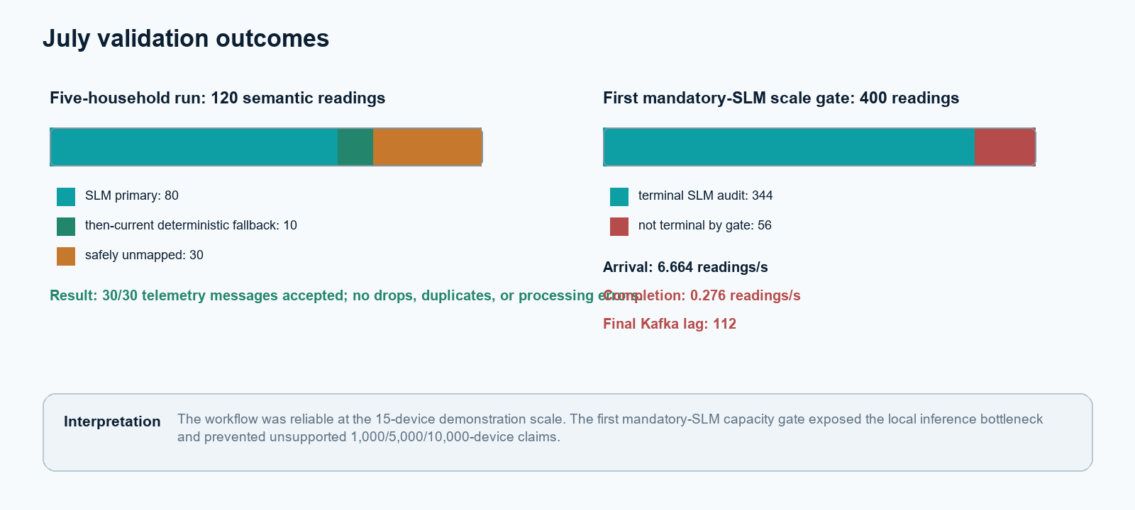
Figure 3. July validation outcomes showing reliable small-scale completion and the first local SLM capacity gate.

Scalability claim boundary
The repository could represent a 10,000-device population, but the first 100-device end-to-end gate did not complete. The 1,000-, 5,000-, and 10,000-device stages were therefore not run in that July validation sequence. Million-device material remained a roadmap.

Late-July stage artifacts later added in the 5 August commit record a separate exact-population workflow that reached 1,000 assets asynchronously. They are listed in the July evidence audit with their execution date and in the August report with their Git provenance. This avoids both ignoring dated evidence and presenting uncommitted work as a fully integrated July release.

11. Validation and Testing
Table 4. Measured five-household run, 20 July 2026
Metric | Result
Households / assets | 5 / 15
Telemetry accepted | 30 / 30
Normalized readings | 120
SLM calls | 120 (100%)
SLM primary / deterministic fallback / safely unmapped | 80 / 10 / 30
Semantic-terminal / IEEE-style rows | 120 / 120
Drops / duplicates / processing errors | 0 / 0 / 0
Gateway average / p95 latency | 13.04 / 14.87 ms
Workflow safety | ready_to_dispatch; simulated; no real execution

Table 5. Customer and public-demo validation during July
Validation area | Evidence | Result
Customer product | 184 service + 5 root + 4 boundary tests; lint/build | Passed
Security gateway | 39 tests; household/operator/admin boundaries | Passed
Semantic connector | 41 tests; 13 live attempts all called SLM | Passed with 6 safe-unmapped
Responsive UI | Desktop, tablet, 320 px mobile | No horizontal overflow
Fleet delivery | 3,436 generated and accepted; 6 retries | 0 drops
Fleet categories | 241 devices across 13 categories | All reached normalized storage
Public boundary | Quick Tunnel, same-origin routes, protected admin | Passed
Fleet semantics | 3,041 terminal audits; 1 valid; 3,040 safe-unmapped | Capacity/quality limitation

12. Customer/Product Development
July converted the dashboard from a validation surface into an EnerShare household product while retaining the original engineering view. The product shows household power, daily energy with measurement/estimate labeling, connected devices, flexibility availability, grid-event state, bounded charts, device details, community aggregates, reports, settings, and validated aggregate insights. Unsupported tariff, carbon, physical export, and real-device metrics are omitted or marked unavailable.
Figure 4 shows the July customer product evidence. The displayed values came through the customer read model rather than from hardcoded random frontend values.
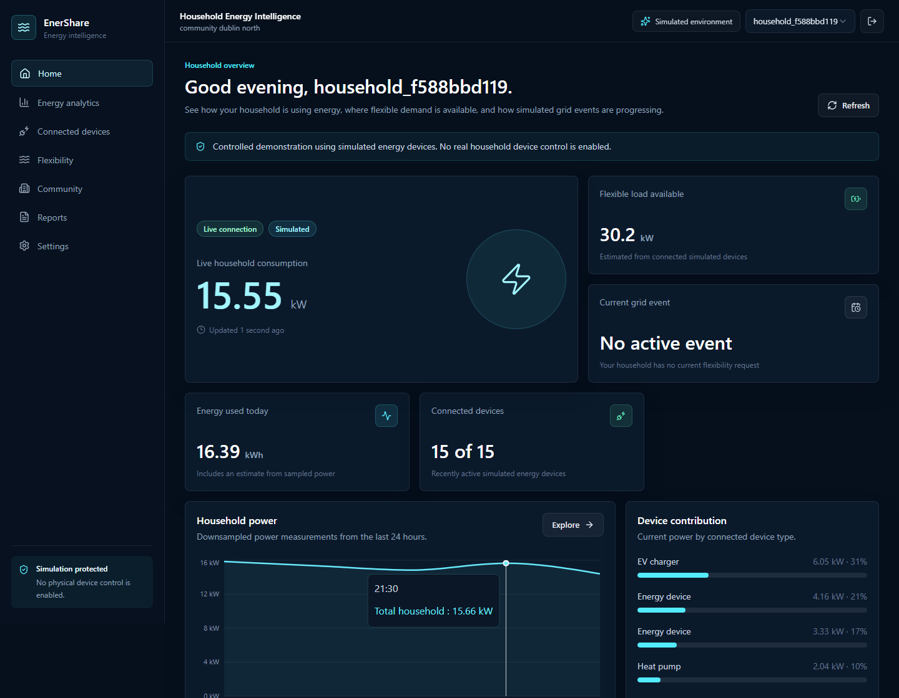
Figure 4. July EnerShare household dashboard with simulated-device notice, live power, energy, flexibility, and bounded household analytics.

The customer API layer applies household scope twice: Next.js validates the signed session and the security gateway re-enforces household/community authorization. Operator selections are pseudonymized. Community comparisons expose aggregates only, and small-group suppression protects privacy. The browser does not connect directly to Kafka, TimescaleDB, Ollama, MQTT, Docker hostnames, or internal service ports.

13. Business Value for EnerShare
Vendor-neutral onboarding: SLM proposals plus SAREF4ENER validation provide a path to interpreting inconsistent manufacturer telemetry.
Customer engagement: the household product translates pipeline data into power, energy, device, and flexibility information without exposing engineering internals.
Operational governance: correlation IDs, durable audits, retries, safe-unmapped outcomes, and role boundaries make failures visible and reviewable.
Grid flexibility readiness: DSO signals can progress through proposal, review, approval, and simulated device-language preparation without physical execution.
Privacy-aware sharing: the dataspace foundation applies pseudonymization, minimization, and aggregate community presentation.
Efficient demonstration: one laptop can represent a mixed household fleet and expose only the protected customer experience through a temporary free tunnel.
Evidence-led investment: the failed capacity gate identifies local inference, not Kafka or the simulator, as the next material engineering constraint.

14. Technical Challenges and Resolutions
Table 6. Technical challenges and resolutions during July
Technical challenge | Impact | Resolution | Result
SLM call exceeded Kafka session | Offset redelivery and duplicate risk | Extended session timeout and enforced SLM timing margin | Final 15-device run had zero final duplicates
Engineering-focused dashboard | Poor customer usability and privacy risk | Product/operations separation plus scoped read model | Customer routes passed boundary tests
Fleet startup burst exceeded rate budget | Transient delivery failures | Distributed schedule and bounded pending retries | 3,436/3,436 accepted; zero drops
Phi-3 throughput and output quality | Backlog and safe-unmapped outcomes | Batch/provider framework and explicit evidence gates | Constraint measured; unsupported claims blocked
Remote demo exposure risk | Potential internal-port or credential leakage | Same-origin BFF, signed sessions, loopback binding, Quick Tunnel only | Public boundary validation passed

15. Safety, Security and Governance
The security gateway remained the production-style external boundary. API-key checks, request-size/content inspection, IP controls, rate limiting, correlation IDs, and audit records protected HTTP routes. Public dashboard mode added signed HTTP-only sessions, secure cookies over HTTPS, login throttling, role checks, same-origin BFF routes, loopback Docker publishing, and removal of internal technical routes for non-admin users.
Semantic governance improved through strict JSON, allowlisted concepts/properties/units, reading-ID reconciliation, confidence checking, command-output rejection, bounded retries, and explicit safely-unmapped terminal records. Raw model prompts and hidden reasoning were not required in customer views. Dataspace output retained community-level usefulness while applying pseudonymization and minimization.
Non-negotiable safety boundary
All household assets and provider responses remained simulated. Approval produced readiness for preparation only. The mock adapter and device translator retained simulated=true and no_real_execution=true. No real credentials, physical device commands, certified IEEE implementation, or certified ENERSHARE connector were introduced.

16. End-of-Month Project Status
Table 7. July end-of-month maturity classification
Classification | Items
Implemented | Multi-household runner; SLM batching/providers; strict audit path; customer read model; product routes; bounded 13-category fleet; public-demo scripts
Validated | 15-device E2E workflow; customer access/build/responsive behavior; gateway workflow; fleet ingestion/normalization; Quick Tunnel boundary
Implemented but under validation | Mandatory-SLM throughput, structured-output quality at fleet scale, larger exact-population stages
Future production infrastructure | GPU/vLLM pool, multi-broker Kafka, production identity/mTLS, HA database, real DSO/device sandboxes, certified connectors

17. Next Development Priorities
The evidence at the end of July supports the following August priorities:
Create an exact, reproducible household and device population rather than a range-random fleet.
Reduce semantic workload carefully to one primary reading per asset for functional population tests without bypassing the mandatory SLM.
Preserve source reading identity across transport retries, normalization, semantic storage, and IEEE storage.
Benchmark locally stable SLM batch sizes and extend strict semantic coverage across all selected categories.
Execute staged 100, 250, 500, and 1,000-asset validations and wait for terminal audit plus zero final lag.
Separate asynchronous functional completion from sustained real-time capacity.
Make customer queries aggregate, searchable, and paginated for a 1,000-asset cohort.
Use measured throughput and storage evidence to model future multi-GPU, multi-broker, and regional infrastructure.

18. Monthly Achievement Summary
Table 8. July management achievement summary
Area | Start of month | Improvement during month | End of month | EnerShare value
Simulation | Three device APIs | Independent runner and 13-category fleet | 15-device validated; 241-device demonstrated | Realistic portfolio evidence
Semantics | SLM-primary small flow | Mandatory batching, providers, strict audit | Scale-aware but locally constrained | Governed interoperability
Product | Technical console | Customer routes, roles, metrics, insights | Separate product and operations | Usable household intelligence
Security/demo | Local gateway | Same-origin public mode and Quick Tunnel | Protected temporary remote access | No-cost stakeholder demonstration
Scalability | Limited evidence | Generator, lag, benchmarks, gates | Bottleneck quantified | Clear investment direction

19. Conclusion
July strengthened AD-FLEX from a complete local technical pipeline into an evidence-led multi-household and customer-facing platform. The five-household validation demonstrated complete, loss-free workflow behavior; the customer read model and product improved usability and privacy; the bounded fleet broadened device representation; and the protected Quick Tunnel established a safe stakeholder demonstration path.
The month also produced a more disciplined semantic architecture. Every reading could be tied to an SLM request, validator decision, retry outcome, durable record, and consumer-lag position. That discipline exposed the central limitation: one local Phi-3 Mini worker could not sustain larger reading rates and did not consistently satisfy strict structured output under the continuous 241-device workload. The project ended July with stronger foundations and a precise August agenda, not with an unsupported high-scale production claim.

Appendix A - Git Evidence
Table 9. Significant July commits reviewed
Date | Commit | Description | Principal components
20 Jul | 3cc24f9 | Simulator telemetry and semantic consumer resilience | BaseDevice, three simulators, validation runner, reports
20 Jul | 2c9231f | Mandatory-SLM scalability foundation | Semantic connector, providers, schema, topics, migrations, scale tooling
24 Jul | 93c10c8 | EnerShare customer dashboard | Read model, roles, BFF, product routes, insight validation
26 Jul | 8ef7b65 | Household fleet and public demo | 241-device fleet, registry, public mode, Quick Tunnel scripts

Pre-July baseline: commit 3d90ee6 dated 15 June 2026. It already contained the Phase 1-9 services and must not be counted as July delivery.

Appendix B - Validation Evidence
docs/multi-household-scalability-validation-report.md
docs/demo-assets/multi-household-validation-results.json
docs/customer-dashboard-testing-report.md
docs/public-demo-validation-report.md
docs/household-fleet-simulator.md
docs/scalability-results/scalability-validation-results.json
docs/scalability-results/scalability-stage-summary.csv
docs/scalability-results/provider-benchmark-batch-1.json
docs/scalability-results/provider-benchmark-batch-4.json
docs/scalability-results/provider-benchmark-batch-8.json
docs/monthly-reports/July_2026_Evidence_Audit.md

Appendix C - Current Limitations
One Windows laptop, one Kafka broker, one TimescaleDB instance, and one local Ollama process are not a production high-availability environment.
The 241-device fleet outpaced semantic processing and produced predominantly safely-unmapped SLM outcomes.
The first 100-device mandatory-SLM capacity gate failed; no 10,000-device end-to-end validation was completed in that sequence.
Public Quick Tunnel URLs are temporary and have no service-level agreement.
Authentication, secrets, mTLS, backup/recovery, monitoring, and consent remain local-development foundations.
All devices and commands are simulated. There is no physical control or production provider credential.
IEEE 2030.5 and ENERSHARE/IDS descriptions are foundations and do not constitute certification.
Tariff savings, carbon reductions, and billing-grade energy accuracy are not supported by the available data.

